***Difect ID:*** 01

***Summery:*** There are unnessery space between ‘’Start Date’’ and date ‘’Input’’

***Description:*** Under ‘’Start Date’’ the space is too large and ‘’date Inpute’’ need to

be directly under ‘’Start Date’’

***Version:*** 1

***Steps:*** 1. Open the ‘’Vacation Booking’’ window

2. In the window appears In the left upper corner ‘’Start Date’’

3. Under ‘’Start Date’’ is the space

4. Than comes ‘’date input’’

***Actual result:*** There are unnessesary space between ‘’Start Date’’ and

‘date input’’

***Expected result:*** There shouldn`t be long space between ‘’Start Date’’ and ‘’date

input’’

***Screenshot:*** 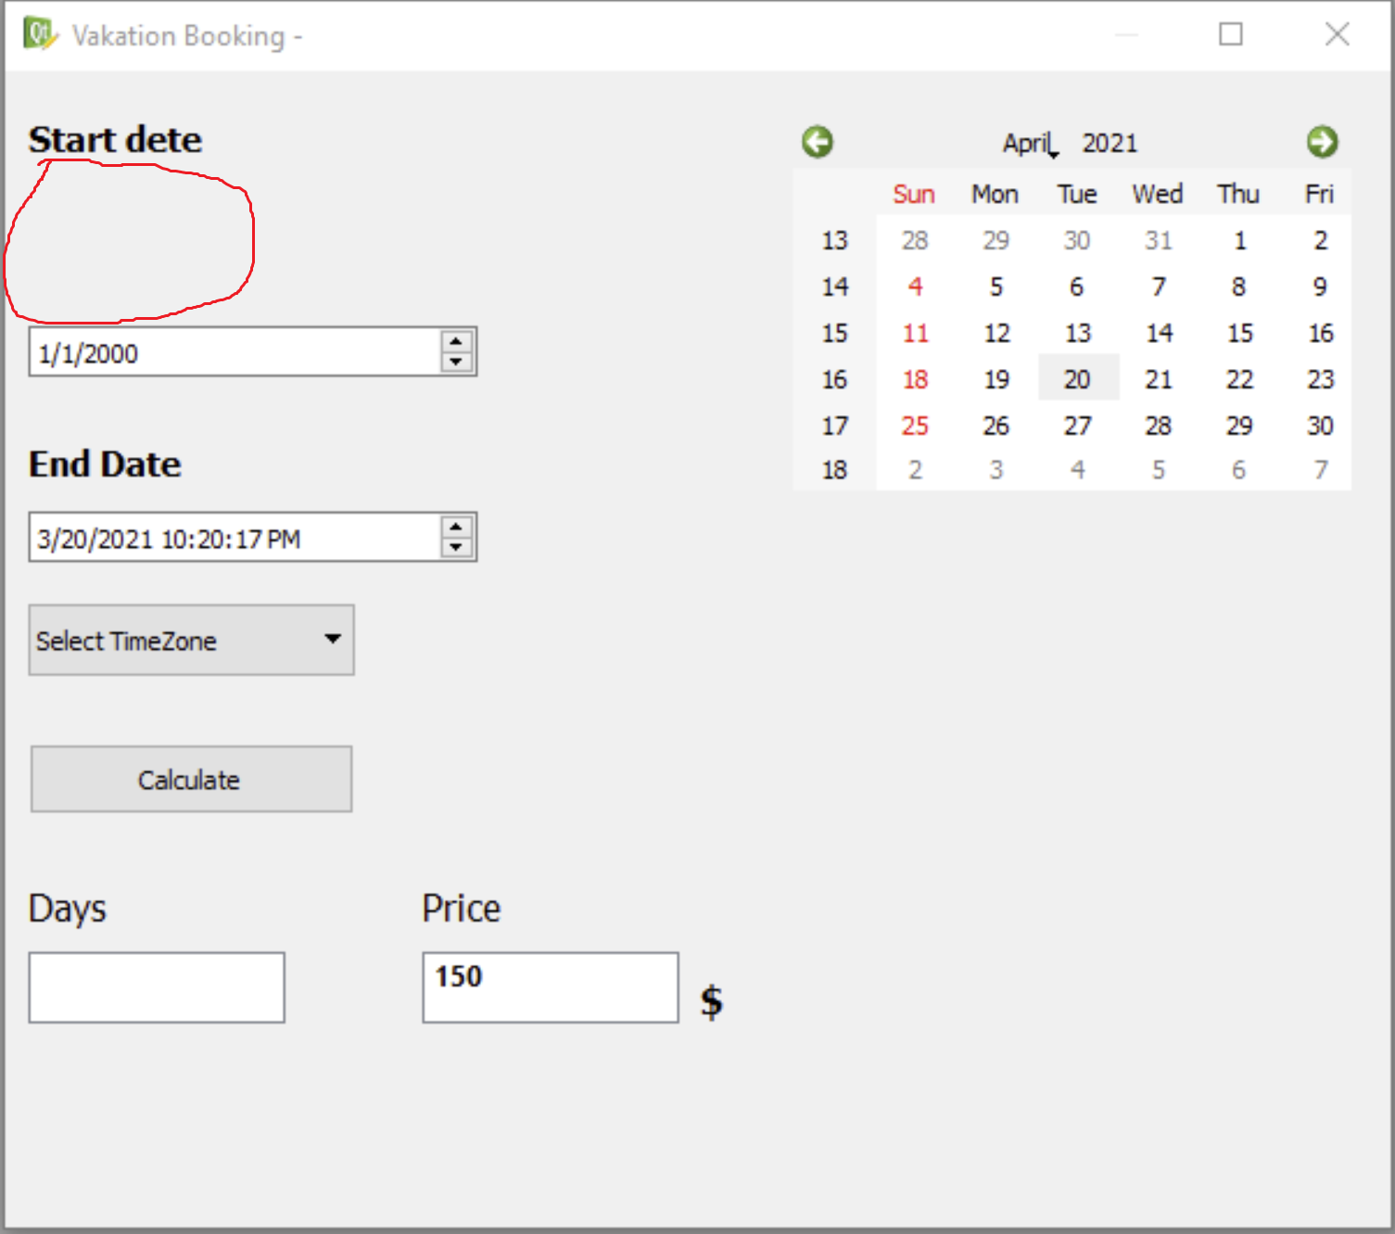

***OS:*** Windows 8.1 64bit

***Date Raised:***  12.07.2022

***Reporter:*** Ofelya Khachatryan

***Severity:***

***Difect ID:***  02

***Summery:*** The ’’dollar sign’’ must be in the middle of the ‘’Price’’ cell`s row

***Description:*** The ‘dollar sign’’ is related with ‘’Price’’ cell

***Version:***  1

***Steps:***  1. Open the ‘’Vacation Booking’’ window

2. In the window appears Indownward‘’Price’’ cell

3. After ‘’Price’’ cell there is a ‘’dollar sign’’

***Actual result:*** The ‘’dollar’’ sign isn`t in the same row as ‘’Price’’ cell

***Expected result:*** The ‘’Dollar’’ sign should bein the same row as ‘’Price’’ cell

***Screenshot:*** 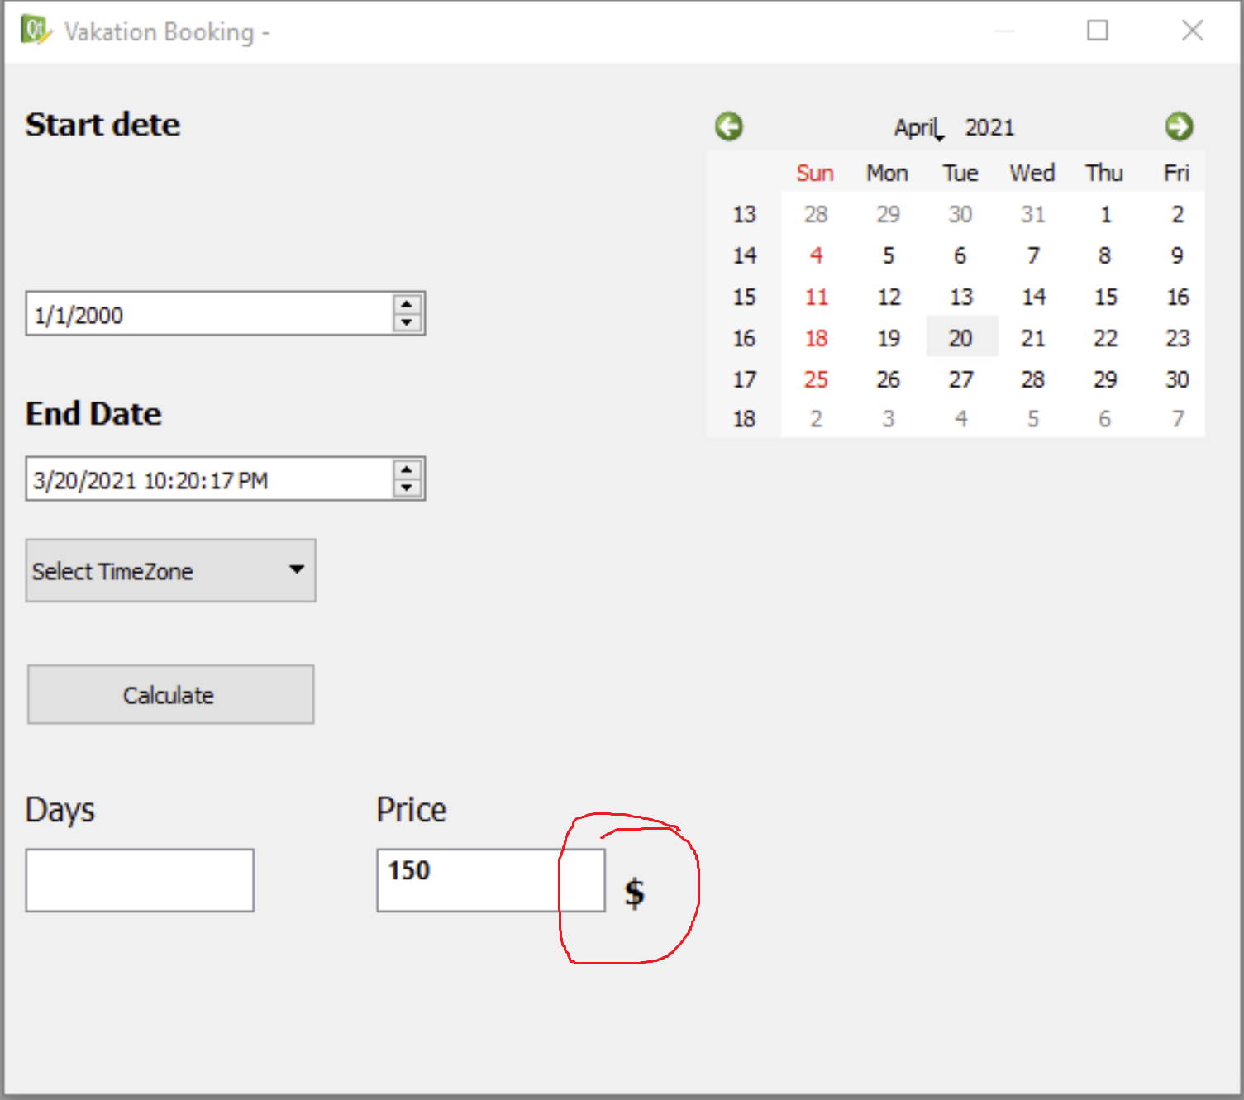

***OS:***  Windows 8.1 64bit

***Date Raised:*** 12.07.2022

***Reporter:*** Ofelya Khachatryan

***Severity:***  Low

***Difect ID:***  03

***Summery:*** In the calendar ‘’sat’’ column is missing

***Description:*** Other days in the calendar are current

***Version:***  1

***Steps:***  1. Open the ‘’Vacation Booking’’ window

2. In the right upper cornerof the window appears

‘’calendar’’

3. In the ‘’Calendar’’ there are weekdays under header

***Actual result:***  There is no ‘’sat’’ column in the ‘’calendar’’

***Expected result:*** There should be all week days(mon, tue, wed, thu, fri, sat, sun) in

The ‘’calendar’’

***Screenshot:*** 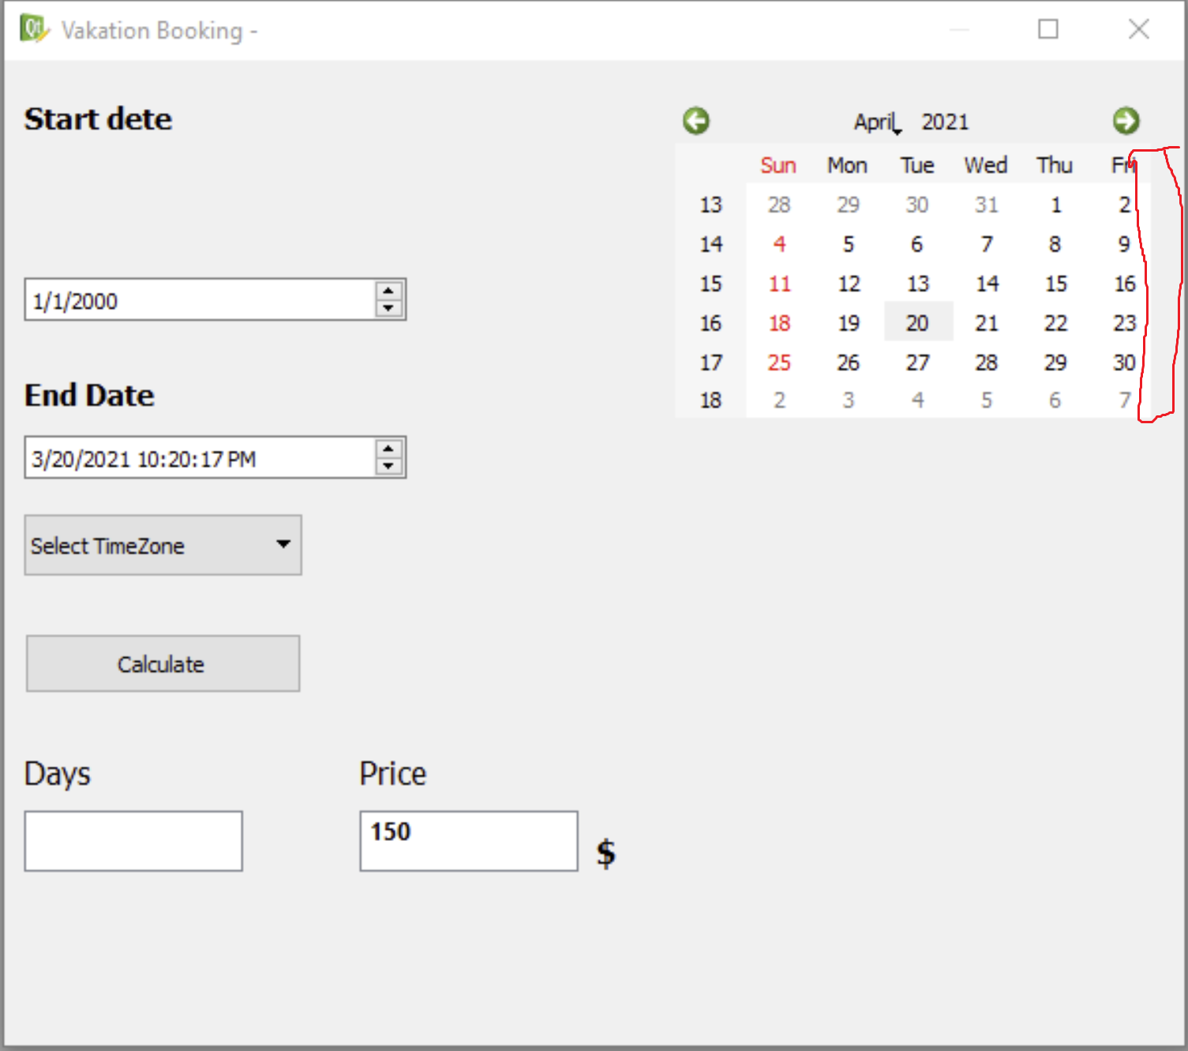

***OS:***  Windows 8.1 64bit

***Date Raised:***  12.07.2022

***Reporter:*** Ofelya Khachatryan

***Severity:***  Critical

***Difect ID:*** 04

***Summery:*** There must be a ‘’dropdown’’ for choosing ‘’Year’’ in calendar

***Description:***  It is missing

***Version:***  1

***Steps:***  1. Open the ‘’Vacation Booking’’ window

2. In the right upper cornerof the window appears

‘’calendar’’

3. In the ‘’calendar’’ in header there are Month and Year

***Actual result:*** There are missing the ‘’dropdown’’ for choosing ‘’Year’’in the

‘’calendar’’

***Expected result:***  There should be a ‘’dropdown’’ for ‘’Year’’in the ‘’calendar’’

***Screenshot:*** 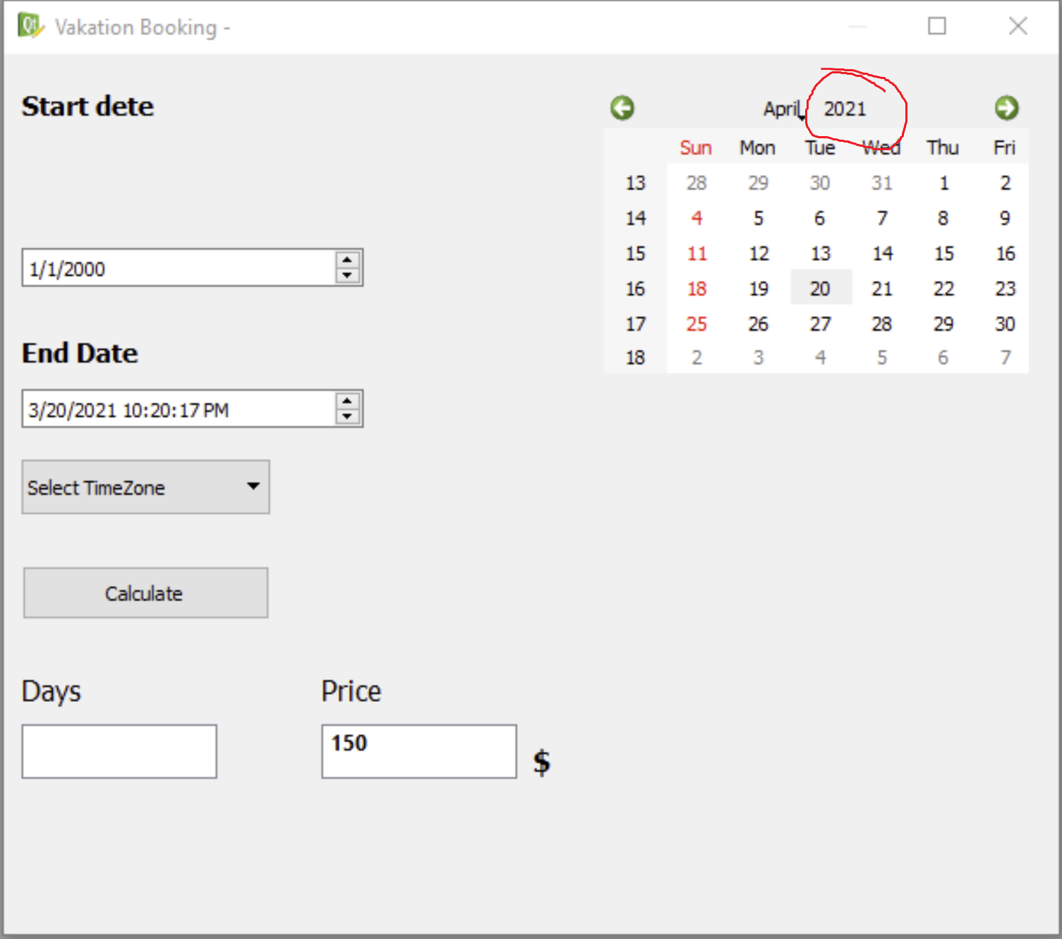

***OS:***  Windows 8.1 64bit

***Date Raised:***  12.07.2022

***Reporter:*** Ofelya Khachatryan

***Severity:*** High